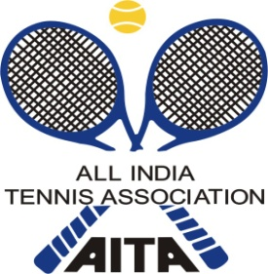
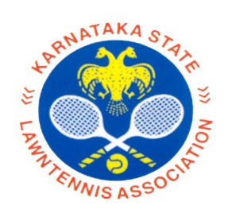


NAME OF THE TOURNAMENT | SPORTSCULT AITA TALENT SERIES(7) UNDER 12 YRS BOYS & GIRLS
NAME OF THE STATE ASSOCIATION | KARNATAKA STATE LAWN TENNIS ASSOCIATION
HONY. SECRETARY OF ASSOCIATION | MR.C.S. SUNDER RAJU
ADDRESS OF ASSOCIATION | KSLTA ,CUBBON PARK ,BANGALORE
AITA Supervisor | Mr K C Nagaraj
TOURNAMENT WEEK | 08TH JAN 2018
ENTRY DEADLINE | 18th DEC 2017
WITHDRAWAL DEADLINE | 01st JAN - 2018
QUALIFYING MATCHES | 06th and 07TH JAN - 18
MAIN DRAW MATCHES | 08TH – JAN - 2018
SIZE OF SINGLES QUALIFYING DRAW | Open
SIZE OF MAIN DRAW | DRAW OF 32
SIZE OF DOUBLES DRAW | DRAW OF 16
QUALIFYING DATE SIGN-IN | 05th JAN 2018
MAIN DRAW SIGN-IN | 07TH JAN 2018

CATEGORY (✓) | TS 7 | ( ✓ )
AGE GROUPS (✓) | U-12 | ( ✓ )

Note: Please send in your entries by email to kiran.i@sportscult.in
SIGN-IN for Qualifying between 12 noon to 2 pm ON FRIDAY 05th Jan 2018 & for Main draw ON SUNDAY 07TH jan 2018 between 12 noon to 2 pm at SPORTSCULT Tennis Academy.

NAME OF THE VENUE |  | SPORTSCULT Tennis Academy
ADDRESS OF VENUE |  | NO: 93, NEAR PRAGATHI SCHOOL, OPP TO STATE BANK OF MYSORE, KUDLU GATE, BOMMANAHALLI, BANGALORE.
TELEPHONE | +91 90710 65452 | Alt Phone | +91 94916 21308
 | +91 85499 69792 | EMAIL | Kiran.i@sportscult.in
COURT SURFACE | Clay | BALLS | AITA Approved Balls
NO. OF COURTS | 4 | FLOODLIT | No
TOURNAMENT DIRECTOR |  | Sri. RAVI KIRAN INDRAKANTI
TELEPHONE | +91 90710 65452 | WEBSITE | WWW.SPORTSCULT.IN
Tournament Referee | N.S.V.S.PRASAD | CELL.NO | 97010 65452

HOTEL DETAILS
NAME | HOTEL EKAA | NAME | OYO ROOMS
ADDRESS | NO:52, HOSUR MAIN ROAD,KUDLU GATE  BENGALORE | ADDRESS | SEE IN WEBSITE NEAR BY BOMMANAHALLI AND KUDLU GATE
DISTANCE | 2 KMS
TELEPHONE | 080-49343499 | TELEPHONE
SEE WEBSITE | GO.IBIBO.COM |  | OYO ROOMS  ( NEAR-KUDLU )

Rules and Regulations:

ENTRY | ENTRIES FOR ONLY ACCEPTANCE LIST CAN BE SENT THROUGH E-MAIL. FOR SIGN-IN TO MAIN DRAW & QUALIFYING, ENTRIES WILL NOT BE ACCEPTED THROUGH MOB / TELEPHONE / E-MAIL. IT IS MANDATORY TO COME AND SIGN – IN AT THE VENUE OF SPORTSCULT TENNIS ACADEMY. PARENTS & PLAYERS ARE REQUESTED TO CO-OPERATE. KSLTA / THE ORGANISERS WILL IN NO WAY ARE RESPONSIBLE FOR THE SIGN IN TAKEN BY PRIVATE AGENCY. ENTRY OF CORRECT AITA NO IS THE RESPONSIBILITY OF THE PLAYER PARTICIPATING.
ENTRY FEE | SINGLES – RS 400  DOUBLES – RS 400 FOR EACH PAIR
SIGN-IN | QUALIFYING : FRIDAY 05TH JAN - 2018 - 12 TO 2 PM
SIGN-IN | MAIN DRAW: SUNDAY 07TH JAN - 2018 - 12 TO 2 PM
AITA REGISTRATION | PLAYERS WITHOUT AITA REGISTRATION NUMBER WILL NOT BE ALLOWED TO PARTICIPATE.  IF IT IS NEW REGISTRATION / RENEWAL, THEN THE COPY OF THE AITA RECEIPT RECEIVED BY MAIL ONLY WILL BE ALLOWED TO PARTICIPATE.
ELIGIBILTY | PLAYERS BORN ON OR AFTER 01.01.2006

