CHAITANYA CREATIONS
 [ALL INDIA TENNIS ASSOCIATION] 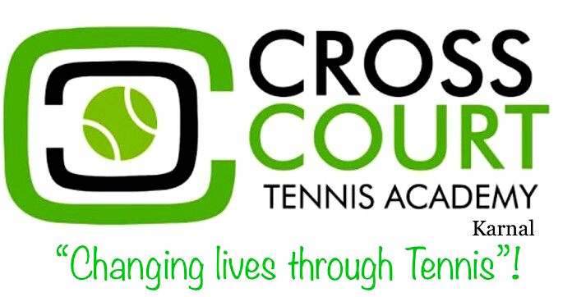
NAME OF THE TOURNAMENT |  |  |  |  |  |  |  |  | CROSS COURT-AITA National Ranking Tennis Championship Rs.50K for Men’s & Women’s JULY-2018
NAME OF THE STATE ASSOCIATION |  |  |  |  |  |  |  |  | HARYANA TENNIS ASSOCIATION
HONY. SECRETARY OF ASSOCIATION |  |  |  |  |  |  |  |  | MR. SUMAN KAPUR
ADDRESS OF ASSOCIATION |  |  |  |  |  |  |  |  | kapursuman@yahoo.com
TOURNAMENT WEEK |  |  |  |  |  |  |  |  | 23rd July to 27th July-2018
THE ENTRY IS TO BE SENT |  |  |  |  |  |  |  |  | Mr.Anup Choudhary
ADDRESS |  |  |  |  |  |  |  |  | CROSS COURT TENNIS ACADEMY  ( A Unit Of Chaitanya Creations)  Sector-33, Adjoining Radha Soami Satsang Bhawan, Near Hotel Noor Mahal ,Phoosgarh Road,  Karnal -132001  Haryana,India
MOBILE NO. |  |  |  |  |  |  |  |  | +91 735 777 777 9
 |  |  |  |  |  |  |  |  | EMAIL |  |  | crosscourttennisacademy@gmail.com
CATEGORY (ü) | Men’s |  |  | ( ü ) |  |  |  |  |  | Women’s |  |  | ( ü )
SIGN-IN |  |  | QUALIFYING |  |  |  |  |  | 20/07/2018  12 P.M. to 02 P.M |  |  |  |  |  |  | MAIN DRAW |  |  | 22/07/2018  12 P.M. to 02 P.M
MAIN DRAW SIZE |  |  | Singles |  |  |  |  |  | 32 |  |  |  |  |  |  | Doubles |  |  | 16
QUALIFYING DRAW SIZE |  |  | Singles |  |  |  |  |  | Open |  |  |  |  |  |  | Doubles |  |  | NA
DATES FOR SINGLES |  |  | QUALIFYING |  |  |  |  |  | 21/07/2018 & 22/07/2018 |  |  |  |  |  |  | MAIN DRAW |  |  | 23/07/2018 to 27/07/2018
DATES FOR DOUBLES |  |  | QUALIFYING |  |  |  |  |  | NA |  |  |  |  |  |  | MAIN DRAW |  |  | 23/07/2018 to 26/07/2018
ENTRY DEADLINE |  |  | 02/06/2018 |  |  |  |  |  | WITHDRAWAL DEADLINE |  |  |  |  |  |  |  |  |  | 16/07/2018

NAME & ADDRESS OF THE VENUE  ROUTE FROM CHANDIGARH: turn left from Nirmal Kutia Chowk/ Noormahal Crossing , cross Noor Mahal chowk and keep straight, turn right from the T-point you will reach the venue |  | CROSS COURT TENNIS ACADEMY  ( A Unit Of Chaitanya Creations)  Sector-33, Adjoining Radha Soami Satsang Bhawan, Near Hotel Noor Mahal ,Phoosgarh Road,  Karnal -132001  Haryana,India  ROUTE FROM DELHI: turn right from Nirmal Kutia Chowk/ Noormahal Crossing , cross Noor Mahal chowk and keep straight, turn right from the T-point you will reach the venue
MOBILE NO. | +91 735 777 777 9 | EMAIL | crosscourttennisacademy@gmail.com
COURT SURFACE | CLAY COURT | BALLS | YONEX TOUR
NO. OF COURTS | 6 | FLOODLIT | 6

TOURNAMENT DIRECTOR |  | ANUP CHOUDHARY
MOBILE NO. | +91 735 777 777 9 | EMAIL | crosscourttennisacademy@gmail.com

TOURNAMENT REFEREE |  | TBA
TELEPHONE |  | TELEFAX
 |  | EMAIL

NOTE-TO GET VIDEO ANALYSIS DONE WITH DEEP AND MEANINGFUL INSIGHTS INTO YOUR MATCH CONTACT THIS NO. 9617556864 (SARTHAK BANSAL)

RULES / REGULATIONS:
MATCH FORMAT | All Main Draw matches will be best of 3 Tie Break Sets.  In case of a Qualifying Draw of 32, matches will be best of 3 tie break sets. No-Ad System of scoring will be used. Doubles will be best of 3 sets. No-Ad System of scoring will be used. Final set will be 10 points Super tie breaker.
ENTRY FEE
  SERIES | (SINGLES & DOUBLES)
  Men’s & Women’s Ranking | Rs.500/- if a player plays Singles, Doubles or Both.
AITA Registration Card | It is mandatory for the player to carry ORIGINAL REGISTRATION CARD for the sign-in. In case the player registration is in process with AITA, has to carry Original receipt or copy of mail from AITA confirming that player registration is in process.
HOTEL DETAILS
NAME | HOTEL PREM PLAZA | NAME | The Jewels
ADDRESS | www.premplaza.com | ADDRESS | www.hoteljewels.in

