[ALL INDIA TENNIS ASSOCIATION]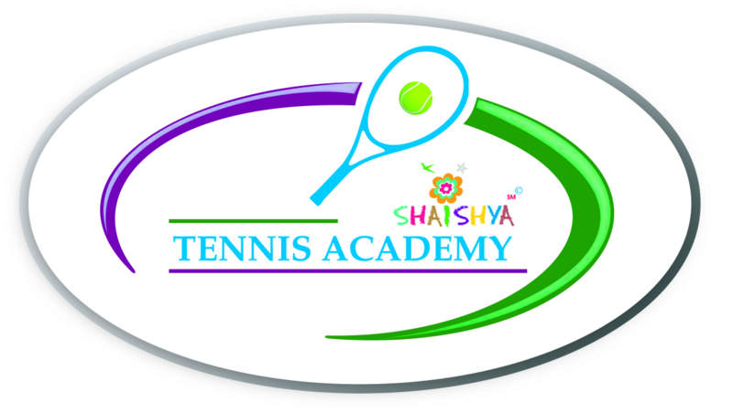
NAME OF THE TOURNAMENT | AITA SHAISHYA CHAMPIONSHIP SERIES UNDER 16 TOURNAMENT
NAME OF THE STATE ASSOCIATION | GUJARAT STATE TENNIS ASSOCIATION
HONY. SECRETARY OF ASSOCIATION | Mr. CHINTAN PARIKH
ADDRESS OF ASSOCIATION  (Venue details are mentioned below) | GUJARAT STATE TENNIS ASSOCIATION,  NEAR. SPORTS CLUB OF GUJ.LTD.  S.P. STADIUM ROAD, NAVRANGPURA. AHMEDABDA 380009
TOURNAMENT DAYS | 2nd to 4th JUNE, 2018

There will be no requirement to send ones entry for this tournament.
Compulsory sign-in on Friday, 1st June between 12 noon to 2 p.m.

NAME OF THE VENUE |  | SHAISHYA TENNIS ACADEMY
ADDRESS OF VENUE |  | SHAISHYA TENNIS ACADEMY,  IN LANE OF ARYAVAT IV,  IN LANE OPPOSITE YMCA  S.G. HIGHWAY,  AHMEDABAD
TELEPHONE | -9687833737,  - 91066 04153 | EMAIL | stagujarat@yahoo.com;  devinder@samasamtennis.com
COURT SURFACE | HARD COURTS – SHADED | BALLS | YONEX
NO. OF COURTS | 4 | FLOODLIT | YES (04)

TOURNAMENT DIRECTOR |  |  | Mr. Shrimal Bhatt
TELEPHONE |  | 9327155400 | EMAIL | shrimal@shrimalbhatt.com
REFEREE | Devinder Singh Bhusari
TELEPHONE |  | 8866050100; 91066 04153 | Email | devinder@samasamtennis.com
(Continued on next page)

CATEGORY | Championship Series (2/3 days)
AGE GROUPS | UNDER 16

SIGN-IN | Friday, 1st June 2018 between 12:00 Noon – 2:00 P M

HOTEL DETAILS

NAME | ADDRESS | CONTACT DETAILS
CORPORATE RESIDENCY | DEV ARC MALL, S.G.HIGHWAY | Phone: 079-26921095  98244 82357
HOTEL AVION INN | 3rd Floor, Aarambh Complex, Opp. Andaz Party Plot,  Nr. Divya Bhaskar, Makarba, S.G.Highway,  (Situated at walking distance  from the venue) | +91 97141 17888  www.hotelavioninn.com
SILVER LEAF HOTEL | GORDHAN THAL, OPP RAJPATH CLUB, SARKHEJ GANDHINAGAR HIGHWAY, | +(91)-(79)-26870111
HOTEL KINGSTON | THALTEJ CROSS ROAD, SARKHEJ GANDHINAGAR ROAD, THALTEJ | +(91)-79-66153404

RESTAURANT DETAILS

NAME | FOOD | DISTANCE
HONEST | PUNJABI, SOUTH INDIAN, SNACKS | 1 K.M
HAVMOR | PUNJABI, SNACKS | 1.5 K.M.
Lots of options for restaurant available on Prahaladnagar Road – 1 k.m. from the venue
(Continued on next page)

RULES / REGULATIONS

As per the AITA new rules the Talent and Championship Series tournament will be conducted in 3 days (Friday will be the sign-in, Saturday & Sunday matches will be played and if required matches may be played on Monday)

ENTRY FEE | SERIES SINGLES DOUBLES  TALENT SERIES RS. 400/- NA  CHAMPIONSHIP SERIES RS. 500/- RS. 600/-  SUPER SERIES RS. 600/- RS. 800/-  NATIONAL SERIES RS. 800/- RS. 1000/-  NATIONALS RS. 1000/- RS. 1200/-

AGE ELIGIBILITY | Players born:  On or after 1st Jan 2002 are eligible for participation in U/16.
DAILY ALLOWANCE | In the case of Championship  Series (3 Day’s) the player will be given the daily allowance from the day he reaches the round of 32  till the day he is eliminated (both singles & doubles) from the tournament.  Daily Allowance for Main Draw players (Singles & Doubles)  • Championship Series: Rs.400 / day

