
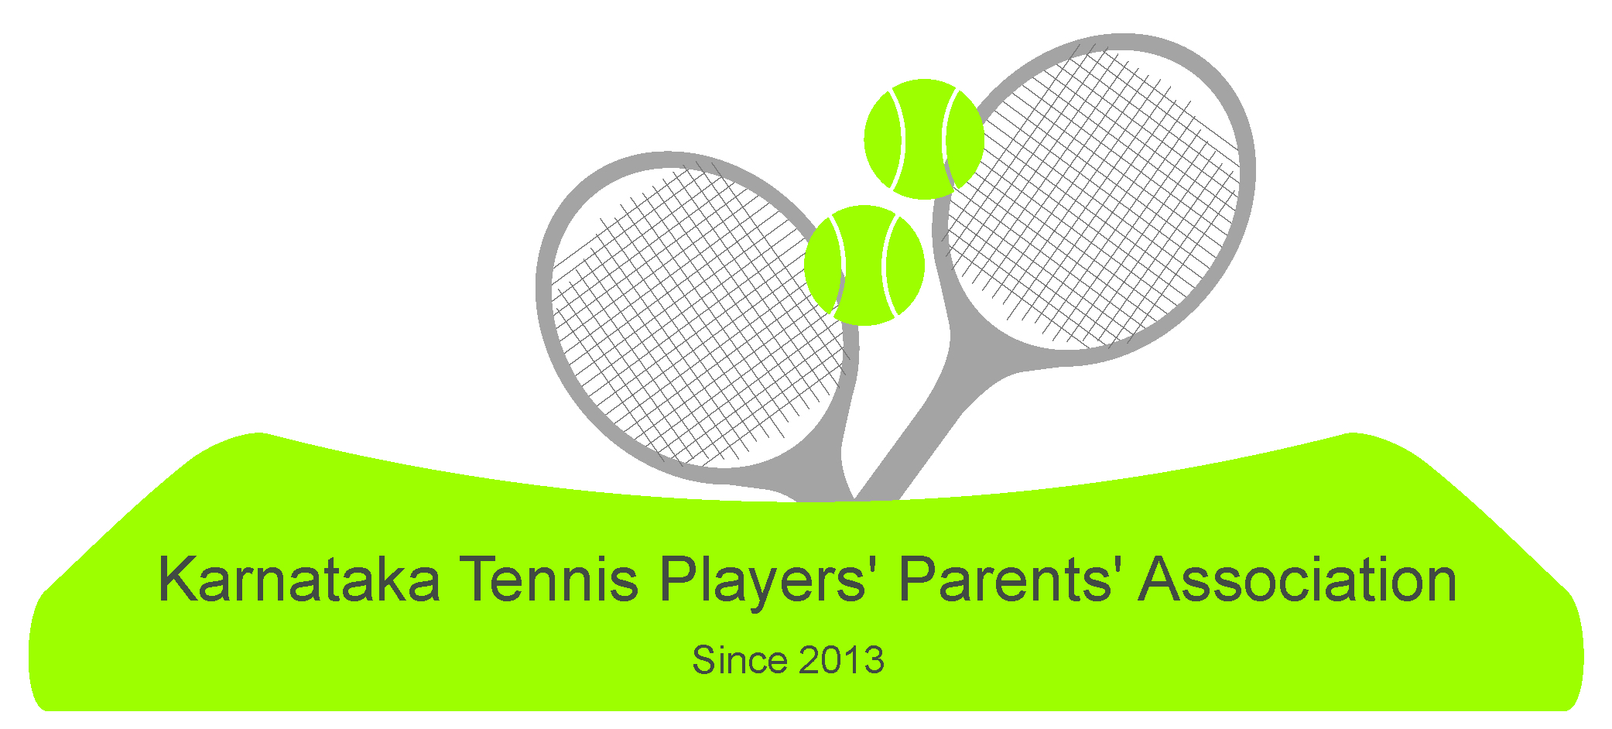
[ALL INDIA TENNIS ASSOCIATION]

NAME OF THE TOURNAMENT | KTPPA – AITA U-18 Championship Series 7 days Tournament 2018
NAME OF THE STATE ASSOCIATION | KARNATAKA STATE LAWN TENNIS ASSOCIATION
HONY. SECRETARY OF ASSOCIATION | SRI. C.S.SUNDER RAJU
ADDRESS OF ASSOCIATION | CUBBON PARK, BANGALORE

TOURNAMENT DIRECTOR: | Mr. Goutham Manjunath | TELEPHONE | 9986298388
AITA SUPERVISOR | Mr. K.C.Nagaraj | TELEPHONE | 94499-75476
CHIEF REFEREE | Mr. Rakshith | TELEPHONE | 7019436836
THE ENTRY IS TO BE SENT  For updates please check katppa.wordpress.com |  | katppa@gmail.com  Mr. Mahesh – 9113099474

CATEGORY (√) | Championship Series
AGE GROUP | U-18 Boys and Girls
SIGN IN :  VENUE: MTC |  |  | QUALIFYING |  |  | 5th Jan 2018  12 to 2 pm | MAIN DRAW |  | 7th Jan 2018  12 to 2 pm
MAIN DRAW SIZE |  |  | Singles |  |  | 32 | Doubles |  | 16
QUALIFYING DRAW SIZE |  |  | Singles |  |  | Open | Doubles |  | NA
DATES FOR SINGLES |  |  | QUALIFYING |  |  | 6-7 Jan 2018 | MAIN DRAW |  | 8 – 12 Jan 2018
DATES FOR DOUBLES |  |  | QUALIFYING |  |  | N/A | MAIN DRAW |  | 9 - 12 Jan 2018
ENTRY DEADLINE |  |  | 18th Dec 2017 |  |  | WITHDRAWAL DEADLINE |  |  | 1st Jan 2018
NAME OF THE VENUE |  |  |  | Mysore Tennis Club – MTC
ADDRESS OF VENUE |  |  |  | Krishnaraj Boulevard, 2nd cross, Chamarajapuram, Mysore - 570005
COURT SURFACE |  | Hard |  |  | BALLS |  |  | AITA approved
NO. OF COURTS |  | 5 |  |  | FLOODLIT |  |  | NA
HOTEL DETAILS
NAME | HOTEL AIRLINES | HOTEL JADE GARDEN
ADDRESS | No 1064 no 16 near law courts,jayalakshmi vilas road chamarajapuram, lakshmipuram Mysuru, Karnataka 570005 | 1064\1, jayalakshmi vilas road near law courts chamarajapuram, Mysuru Karnataka 570005
Tariff | 1500 | 2000
TELEPHONE | 0821- 2330745 | 0821- 4008222
DISTANCE | 500 mts from the academy

RULES / REGULATIONS
ENTRY | Entry can be sent by EMAIL. No telephone entry or sign-in will be accepted. Players need to be registered with AITA (Mandatory). Signing-in at the venue[MTC] is compulsory
AGE ELIGIBILITY | Players born on or after 1st Jan 2000 are eligible for participation.
ENTRY FEE | Singles: Rs.500  Doubles: Rs.600 FOR EACH PAIR
SIGN-IN | MAIN DRAW :  QUALIFYING: FRIDAY : 5th Jan 2018 12 TO 2 P.M  SINGLES : SUNDAY : 7th Jan 2018 12 to 2 P.M  DOUBLES: MONDAY : 8th Jan 2018 before 12 noon
AITA REGISTRATION | PLAYERS WITHOUT AITA REGISTRATION NUMBER WILL NOT BE ALLOWED TO PARTICIPATE.  IF IT IS NEW REGISTRATION / RENEWAL, THEN THE COPY OF THE AITA RECEIPT RECEIVED BY MAIL ONLY WILL BE ALLOWED TO PARTICIPATE.
DAILY ALLOWANCE | RS.400 FOR MAIN DRAW PLAYERS ONLY.

