[ALL INDIA TENNIS ASSOCIATION]
NAME OF THE TOURNAMENT | ALL INDIA CHAMPIONSHIP SERIES FOR BOYS AND GIRLS UNDER 16 AITA TS -7
NAME OF THE STATE ASSOCIATION | U.P.STATE TENNIS ASSOCIATION
HONY. SECRETARY OF ASSOCIATION | C.P. KACKAR (M) 9335816762
ADDRESS OF ASSOCIATION | 4, PARK ROAD, LUCKNOW
TOURNAMENT WEEK | 19th October 2015
ENTRY DEADLINE | 28th September 2015
WITHDRAWAL | 12th October 2015

THE ENTRY IS TO BE SENT |  | noidatennis@yahoo.com
ADDRESS OF VENUE |  | Gaur City I, Gaur city stadium (nearby 4 murti Chauk)  Noida Extension  Connectivity  - 13 km from Kalindi Kunj  - 7 km from Noida City center Sector 32  - 2 KM from NH 24
TELEPHONE | +91 120- 2424854/55 | FAX | ********
 | +91 9136378896 | EMAIL | noidatennis@yahoo.com
ON COURT MOBILE NO. | +91 9818366733  +91 9717994030

CATEGORY () | N | ( ) | NS | ( ) | SS | ( ) | CS | ( ) | TS | ( )
AGE GROUPS () | U-12 | ( ) | U-14 | ( ) | U-16 | ( ) | U-18 | ( )
 | Men’s | ( ) |  | Women’s |  | ( )

SIGN-IN | QUALIFYING  16/10/2015 | 12-2 pm  (Friday) |  | MAIN DRAW  18/10/2015 | 12-2 pm  (Sunday)
MAIN DRAW SIZE | Singles | 32 |  | Doubles | 16
QUALIFYING DRAW SIZE | Singles | Open |  | Doubles | NA
DATES FOR SINGLES | QUALIFYING | 17&18 Oct 2015 |  | MAIN DRAW | 19 Oct2015 ONWARD

Please conform your entry on 13th October 2015 between - 3:00 pm to 4:00 pm Mr. Kuldeep cont. +91 9717994030

COURT SURFACE | SYNTHETIC- 3 CLAY -2 |  | FAX | Not accepted
FLOODLIT | YES |  | BALLS | AITA approved.

TOURNAMENT REFEREE
RAJAT THAKUR +91 9136378896
TOURNAMENT DIRECTOR | VIVEK ANAND  +91 9818366733 |  | EMAIL | noidatennis@yahoo.com

ENTRY FEE | SERIES SINGLES FEE DOUBLES FEE  TS Boys & Girls U-16 Rs. 400/- Rs 400/- pair
AITA Registration Card | It is mandatory for the player to carry ORIGINAL REGISTRATION CARD for the sign-in. In case the player registration is in process with AITA, the player has to carry Original receipt or copy of mail from AITA confirming that player registration is in process.

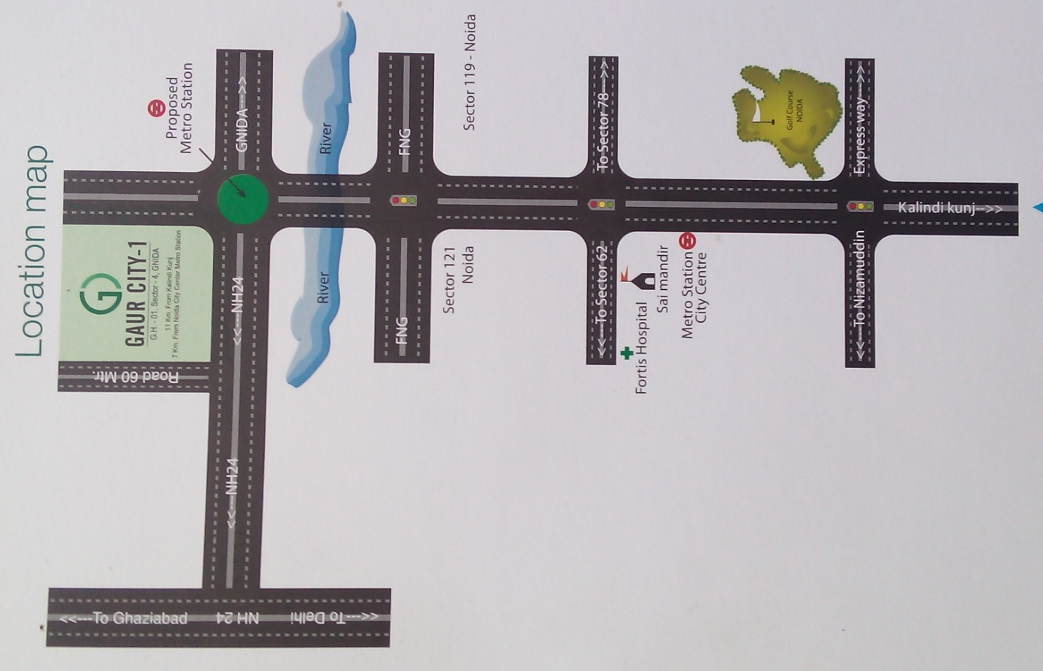
HOTEL DETAILS

NAME | Hotel Shree Krishna
ADDRESS | Hotel Rama sec-35 near Noida City center metro station  Cont :- 9717994030

