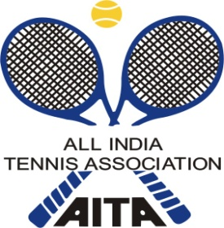

NAME OF THE TOURNAMENT | Tennis Temple Academy  AITA Talent Series (3)
NAME OF THE STATE ASSOCIATION | KARNATAKA STATE LAWN TENNIS ASSOCIATION
HONY. SECRETARY OF ASSOCIATION | SRI. C.S.SUNDER RAJU
ADDRESS OF ASSOCIATION | CUBBON PARK, BANGALORE

TOURNAMENT DIRECTOR: | Mr. Niranjan Ramesh | TELEPHONE | 9901893601
CHIEF REFREE | Mr.Akshay kishore | TELEPHONE | 9008959789
Tennis temple  REPRESENTATIVE | Ms. kowsalya | TELEPHONE | 7022654589
TOURNAMENT WEEK |  | 16 NOVEMBER 2015

CATEGORY (√) | Under 14 yrs Boys /Girls ( 3 DAYS TOURNAMENT)
Tournament dates |  | 14,15,16th NOVEMBER 2015 | SIGN IN DATE | 13TH NOVEMBER 2015  12:00 TO 14:00 PM noon

NAME OF THE VENUE |  | Tennis Temple Academy
ADDRESS OF VENUE |  | Venue – #174,dasashrama, near panduranga temple, 5TH block Rajajinagar, , Bengaluru: 560010
COURT SURFACE | 5 Clay COURTS |  | BALLS | AITA Approved –wilson
NO. OF COURTS | 5 |  | FLOODLIT | NA
WEBSITE |  |  | Tennistemple.in

HOTEL DETAILS

NAME | Mallika Residency
ADDRESS | 43, Dr Rajkumar Rd, Prakash Nagar, Rajajinagar, Bengaluru, Karnataka 560021
SINGLE (AC)
DOUBLE (AC) | 2200 INR
TELEPHONE | 080 4127 7777
DISTANCE | 1 kms from the academy

RULES / REGULATIONS

ENTRY | Entry not required to be sent, Direct sign-in at the venue on Friday 13TH NOV. 2015 between 12:00 pm to 2:00 pm.
MATCH FORMAT | The tournament will have an open draw with no qualifying or main draw.
DAILY ALLOWANCE | No DA, being TS tournament
ENTRY FEE | Singles: Rs.400/- per player
AITA Registration Card | It is mandatory for the player to carry ORIGINAL REGISTRATION CARD for the sign-in.

