ALL INDIA TENNIS ASSOCIATION
NAME OF THE TOURNAMENT | SPORTS SHALA AITA TALENT SERIES - 7  Boys & Girls U-16
NAME OF THE STATE ASSOCIATION | HARYANA TENNIS ASSOCIATION
HONY. SECRETARY OF THE ASSOCIATION | MR. SUMAN KAPUR
ADDRESS OF ASSOCIATION | kapursuman@yahoo.com
TOURNAMENT WEEK | WEEK : 23RD OCTOBER 2017  ENTRY DEADLINE : 2TH OCTOBER 2017  WITHDRAWAL : 16TH OCTOBER 2017
THE SCHEDULE WILL BE UPLOADED ON OUR FACEBOOK PAGE WWW.FACEBOOK.COM/SPORTSSHALAINDIA & WEBSITE WWW.SPORTSSHALA.COM AFTER 8PM ON THE PREVIOUS EVENING. NO REQUEST FOR TIMINGS WILL BE ACCEPTED.

THE ENTRY IS TO BE SENT BY EMAIL ONLY:  Name, AITA No., DOB, Category, Contact No. & Tournament Week applying for, to | SACHIN BHATAGAR  ananya.paul@passerinegroup.com
ADDRESS OF THE VENUE | SPORTS SHALA,  SECTOR -65, GOLF COURSE EXTENSION ROAD, INSIDE EMAAR MGF COMPLEX, EMERALD HILLS  GURGAON (HARYANA)
TOURNAMENT DIRECTOR | SACHIN BHATAGAR: +91 9711772894
TOURNAMENT REFEREE | Mr. Jaswant Nigam: +91 9911346692

CATEGORY () | N | ( ) | NS | ( ) | SS | ( ) | CS | ( ) | TS | ( )
AGE GROUPS () | U-12 | ( ) | U-14 | ( ) | U-16 | ( ) | U-18 | ( )
 | Men’s | ( ) |  | Women’s |  | ( )

AGE ELIGIBILITY | Players born:  After 1st Jan 2003 are eligible for participation in U/14  After 1st Jan 2001 are eligible for participation in U/16
ENTRY FEE | SERIES SINGLES FEE DOUBLES FEE  TS Boys & Girls Rs. 400/- Rs 400/- pair
SIGN-IN | QUALIFYING DRAW: 20/10/2017  12-2PM |  |  | MAIN DRAW: 22/10/2017  12-2PM
QUALIFYING DRAW SIZE | SINGLES | OPEN |  | DOUBLES |  | N/A
MAIN DRAW SIZE | SINGLES | 32 |  | DOUBLES |  | 16
ENTRY DEADLINE | 2ND OCTOBER 2017 |  | WITHDRAWAL DEADLINE |  | 16TH OCTOBER 2017
HOTEL DETAILS
NAME | OYO ROOMS (5.0 kms) | OYO ROOMS (7.9 kms)
ADDRESS | Near Double Tree by Hilton,  Sector- 56 | OYO Premium,  Golf Course Road,  Sector- 54
TARIFF
SINGLE | 1,299 PER ROOM
DOUBLE | 1,499 PER ROOM / 750 PER OCCUPANCY
TRIPLE | 1,799 PER ROOM / 600 PER OCCUPANCY
THE ABOVE MENTIONED ROOMS ARE INCLUSIVE OF BREAKFAST, WIFI & TAXES.

RULES / REGULATIONS

ENTRY & DIRECTIONS | No entry for Main Draw will be accepted through telephone. Please carry your Original AITA ITN Card for sign in On SIGN IN DAY 12-2 pm  QUALIFYING SIGN-IN: 20TH OCTOBER 2017, 12-2PM  QUALIFYING MATCHES: 21ST – 22ND OCTOBER 2017, 8AM – 8PM  MAIN DRAW SIGN-IN: 22ND OCTOBER 2017, 12-2PM  MAIN DRAW MATCHES: 23RD – 27TH OCTOBER, 8AM – 8PM

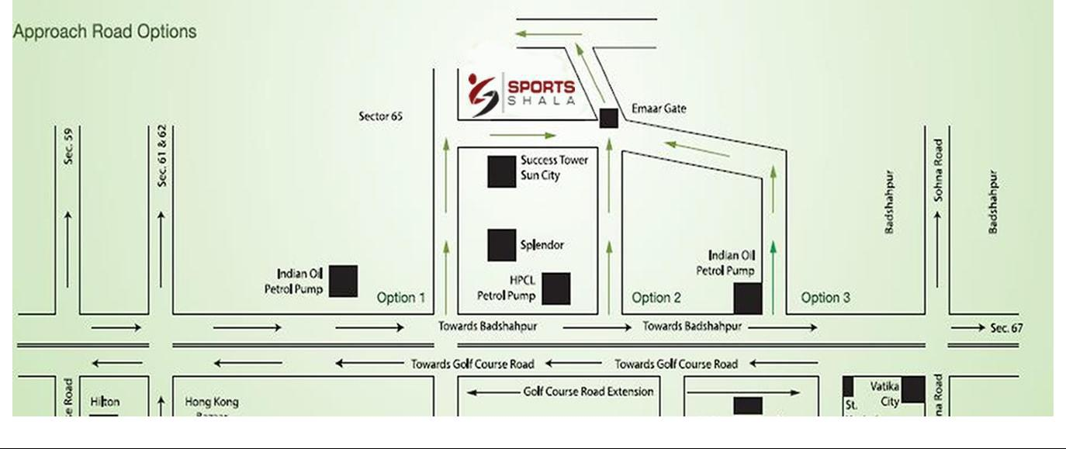
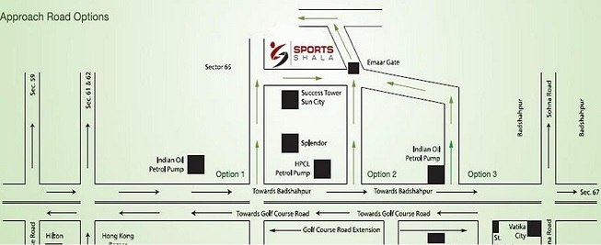

COURT SURFACE | CLAY | NO. OF COURTS: | 5 | BALLS | BABOLAT

