ALL INDIA TENNIS ASSOCIATION

 |  |  |  |  |  |  |  |  |  |  |  |  |  |  |  |  |  |  |  |  |  |  |  |  |  |  | SPORTS SHALA AITA TALENT SERIES - 7
 |  | NAME OF THE TOURNAMENT
 |  |  |  |  |  |  |  |  |  |  |  |  |  |  |  |  |  |  |  |  |  |  |  |  |  |  | Boys & Girls U-12
 |  | NAME OF THE STATE ASSOCIATION |  |  |  |  |  |  |  |  |  |  |  |  |  |  |  |  |  |  |  |  |  |  |  |  | HARYANA TENNIS ASSOCIATION
 |  | HONY. SECRETARY OF THE ASSOCIATION |  |  |  |  |  |  |  |  |  |  |  |  |  |  |  |  |  |  |  |  |  |  |  |  | MR. SUMAN KAPUR
 |  | ADDRESS OF ASSOCIATION |  |  |  |  |  |  |  |  |  |  |  |  |  |  |  |  |  |  |  |  |  |  |  |  | kapursuman@yahoo.com
 |  | TOURNAMENT WEEK |  |  |  |  |  |  |  |  |  |  |  |  |  |  |  |  |  |  |  |  |  |  |  |  | WEEK : 27TH NOV 2017
 |  |  |  |  |  |  |  |  |  |  |  |  |  |  |  |  |  |  |  |  |  |  |  |  |  |  | ENTRY DEADLINE: |  |  |  |  |  |  |  |  |  |  |  |  |  | 6TH NOV 2017
 |  |  |  |  |  |  |  |  |  |  |  |  |  |  |  |  |  |  |  |  |  |  |  |  |  |  | WITHDRAWAL : 20TH NOV 2017
 |  |  |  |  |  |  | THE SCHEDULE WILL BE UPLOADED ON OUR FACEBOOK PAGE
 |  | WWW.FACEBOOK.COM/SPORTSSHALAINDIA & WEBSITE WWW.SPORTSSHALA.COM AFTER 8PM
 |  |  |  | ON THE PREVIOUS EVENING. NO REQUEST FOR TIMINGS WILL BE ACCEPTED.
 |  | THE ENTRY IS TO BE SENT BY EMAIL ONLY |  |  |  |  |  |  |  |  |  |  |  |  |  |  |  |  |  |  |  |  |  |  |  |  | SACHIN BHATNAGAR
 |  |  |  |  |  |  |  |  |  |  |  |  |  |  |  |  |  |  |  |  |  |  |  |  |  |  | aita@passerinegroup.com
 |  |  |  |  |  |  |  |  |  |  |  |  |  |  |  |  |  |  |  |  |  |  |  |  |  |  | SPORTS SHALA,
 |  | ADDRESS OF THE VENUE |  |  |  |  |  |  |  |  |  |  |  |  |  |  |  |  |  |  |  |  |  |  |  |  | SECTOR -65, GOLF COURSE EXTENSION ROAD, INSIDE
 |  |  |  |  |  |  |  |  |  |  |  |  |  |  |  |  |  |  |  |  |  |  |  |  |  |  | EMAAR MGF COMPLEX, EMERALD HILLS
 |  |  |  |  |  |  |  |  |  |  |  |  |  |  |  |  |  |  |  |  |  |  |  |  |  |  | GURGAON (HARYANA)
 |  | TOURNAMENT DIRECTOR |  |  |  |  |  |  |  |  |  |  |  |  |  |  |  |  |  |  |  |  |  |  |  |  | SACHIN BHATNAGAR
 |  |  |  |  |  |  |  |  |  |  |  |  |  |  |  |  |  |  |  |  |  |  |  |  |  |  | +91 9711772894
 |  | TOURNAMENT REFEREE |  |  |  |  |  |  |  |  |  |  |  |  |  |  |  |  |  |  |  |  |  |  |  |  | Mr. Jaswant Nigam
 |  |  |  |  |  |  |  |  |  |  |  |  |  |  |  |  |  |  |  |  |  |  |  |  |  |  | +91 9911346692
 |  | CATEGORY |  | (✓) |  |  |  |  |  | N |  | ( |  |  | ) |  |  | NS |  |  |  |  | ( |  |  |  | ) |  |  | SS |  |  |  | ( | ) |  |  |  | CS |  |  |  |  |  |  | ( | ) |  |  | TS |  | ( | ✓
 |  |  |  |  |  |  |  |  |  |  |  |  |  |  |  |  |  |  |  |  |  |  |  |  |  |  |  |  |  |  |  |  |  |  |  |  |  |  |  |  |  |  |  |  |  |  |  |  |  |  |  |  | )
 |  | AGE GROUPS |  |  | (✓) |  |  |  |  | U-12 |  | (✓ ) |  |  |  |  |  | U-14 |  |  |  |  | ( ) |  |  |  |  |  |  | U-16 |  |  |  | ( | ) |  |  |  | U-18 |  |  |  |  |  |  | ( | )
 |  |  |  |  |  |  |  |  |  | Men’s |  | ( ) |  |  |  |  |  |  |  |  |  |  | Women’s |  |  |  |  |  |  |  |  |  |  | ( | )
 |  |  |  |  |  |  |  |  |  |  |  |  |  |  |  | Players born:
 |  | AGE ELIGIBILITY |  |  |  |  |  |  |  |  |  |  |  |  |  | After 1st Jan 2005 are eligible for participation in U-12
 |  |  |  |  |  |  |  |  |  |  |  |  |  |  |  | After 1st Jan 2003 are eligible for participation in U-14
 |  |  |  |  |  |  |  |  |  |  |  |  |  |  |  |  |  | SERIES |  |  |  |  |  |  |  |  |  |  |  | SINGLES FEE |  |  |  |  |  |  |  |  |  |  |  |  |  |  |  |  | DOUBLES FEE
 |  |  |  |  |  |  |  |  |  |  |  |  |  |  |  |  | TS Boys & Girls |  |  |  |  |  |  |  |  |  |  |  |  |  |  | Rs. 400/- |  |  |  |  |  |  |  |  |  |  |  |  |  |  | Rs. 400/- pair
 |  | ENTRY FEE
 |  |  |  |  |  |  |  |  |  |  |  |  |  |  |  |  | CS Boys & Girls |  |  |  |  |  |  |  |  |  |  |  |  |  |  | Rs. 500/- |  |  |  |  |  |  |  |  |  |  |  |  |  |  | Rs. 600/- pair
IGN-IN |  |  |  |  |  |  |  | QUALIFYING DRAW: 24TH-NOV-2017 |  |  |  |  |  |  |  |  |  |  |  |  |  |  |  |  |  |  |  |  |  |  | MAIN DRAW: 26TH-NOV-2017
 |  |  |  |  |  |  |  | 12-2PM |  |  |  |  |  |  |  |  |  |  |  |  |  |  |  |  |  |  |  |  |  |  |  |  |  |  |  |  |  |  |  |  |  |  | 12-2PM
QUALIFYING |  |  |  |  |  |  |  | SINGLES |  |  |  |  |  |  |  |  |  |  |  |  |  | OPEN |  |  |  |  |  |  |  |  | DOUBLES |  |  |  |  |  |  |  |  |  |  |  |  |  |  |  |  | N/A
DRAW SIZE
MAIN DRAW SIZE |  |  |  |  |  |  |  | SINGLES |  |  |  |  |  |  |  |  |  |  |  |  |  | 32 |  |  |  |  |  |  |  |  | DOUBLES |  |  |  |  |  |  |  |  |  |  |  |  |  |  |  |  | 16
ENTRY DEADLINE |  |  |  |  |  |  |  | 6TH NOV 2017 |  |  |  |  |  |  |  |  |  |  |  |  |  |  |  | WITHDRAWAL DEADLINE |  |  |  |  |  |  |  |  |  |  |  |  |  |  |  |  |  |  | 20TH NOV 2017
 |  |  |  |  |  |  |  |  |  |  |  |  |  |  |  |  |  |  |  | HOTEL DETAILS
NAME |  |  | OYO ROOMS (5.0 kms) |  |  |  |  |  |  |  |  |  |  |  |  |  |  |  |  |  |  |  |  |  |  |  |  |  | OYO ROOMS (7.9 kms)
 |  |  | Near Double Tree by Hilton, |  |  |  |  |  |  |  |  |  |  |  |  |  |  |  |  |  |  |  |  |  |  |  |  |  | OYO Premium,
ADDRESS |  |  | Sector- 56 |  |  |  |  |  |  |  |  |  |  |  |  |  |  |  |  |  |  |  |  |  |  |  |  |  | Golf Course Road,
 |  |  |  |  |  |  |  |  |  |  |  |  |  |  |  |  |  |  |  |  |  |  |  |  |  |  |  |  | Sector- 54
 |  |  |  |  |  |  |  |  |  |  |  |  |  |  |  |  |  |  |  | TARIFF
SINGLE |  |  |  |  |  |  |  |  |  |  |  |  |  |  |  |  |  |  |  | 1,299 PER ROOM
DOUBLE |  |  | 1,499 PER ROOM / 750 PER OCCUPANCY
TRIPLE |  |  | 1,799 PER ROOM / 600 PER OCCUPANCY

THE ABOVE MENTIONED ROOMS ARE INCLUSIVE OF BREAKFAST, WIFI & TAXES.

RULES / REGULATIONS

No entry for Main Draw will be accepted through telephone. Please carry your Original AITA ITN Card for sign in On SIGN IN DAY 12-2 pm

_{ENTRY & DIRECTIONS} QUALIFYING SIGN-IN: 24TH NOV 2017, 12-2PM
QUALIFYING MATCHES: 25TH-26TH NOV 2017, 8AM – 8PM

MAIN DRAW SIGN-IN: 26TH NOV 2017, 12-2PM MAIN DRAW MATCHES: 27TH NOV – 1TH DEC 2017, 8AM – 8PM
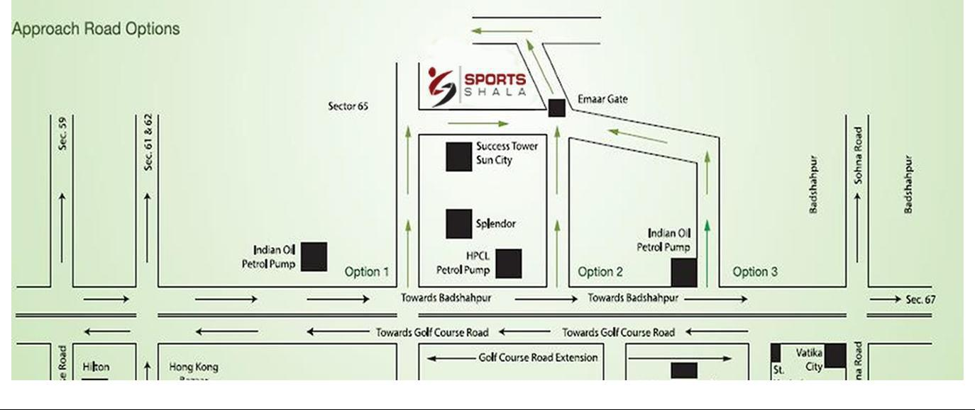

COURT |  |  |  | NO. OF
 |  | CLAY |  |  |  | 5 |  | BALLS |  | BABOLAT
SURFACE |  |  |  | COURTS:

