ALL INDIA TENNIS ASSOCIATION
 | NAME OF THE TOURNAMENT |  |  | AMBALA AITA TS – 7 Boys & Girls U-14 & 16
 | NAME OF THE STATE ASSOCIATION |  |  | HARYANA TENNIS ASSOCIATION
 | HONY. SECRETARY OF THE ASSOCIATION |  |  | MR. SUMAN KAPUR
 | ADDRESS OF ASSOCIATION |  |  | kapursuman@yahoo.com
 | TOURNAMENT WEEK |  |  | WEEK : 31ST AUGUST 2015  ENTRY DEADLINE: 20THAUGUST 2015  WITHDRAWAL : 24TH AUGUST 2015
 | QUALIFYING SIGN-IN:  QUALIFYING MATCHES:  MAIN DRAW SIGN-IN:  MAIN DRAW MATCHES: |  |  | 28TH AUG 2015, 12-2PM  29TH & 30th AUG 2015  30TH AUG 2015, 12-2PM  31ST AUG – 4TH SEP
 | THE ENTRY IS TO BE SENT BY EMAIL ONLY |  |  | ashwani.lta@gmail.com
 | ADDRESS OF THE VENUE |  |  | Ashwani Lawn Tennis Academy , Delhi public school . Ambala Chandigarh highway opp. Omaxe greens, Ambala city 134003 (HARYANA)
 | CONTACT DETAILS |  |  | Ashwani kumar  Ph – +917206086555  Yuvraj Goel  Ph- +918607009520
MAIN DRAW SIZE |  | Singles | 32 |  | Doubles | 16
QUALIFYING DRAW SIZE |  | Singles | Open |  | Doubles | NA
COURT SURFACE |  | CLAY | BALLS |  | AITA APPROVED
NO. OF COURTS |  | 04 | FLOODLIT |  | NO
HOTEL DETAILS
NAME | PARADISE TOURIST RESORT (0.3 kms) | GRAND PACIFIC RETREAT (0.33 Kms)
PHONE NUMBERS | 0171–2541642 (O)  096712-93799 (M)  094664-19646 (M) | +91-0171-2540642  2540643  098967-09483
TARIFF
 | CONTACT THE NUMBERS GIVEN ABOVE

RULES / REGULATIONS
ENTRY | No entry will be accepted through telephone.  Please carry your Original AITA ITN Card for sign in On SIGN IN DAY 12-2 pm to escape a penalty of Rs. 100/-
AGE ELIGIBILITY | Players born:  After 1st Jan 2001 are eligible for participation in U/14  After 1st Jan 1999 are eligible for participation in U/16
ENTRY FEE | SERIES SINGLES FEE DOUBLES FEE  TS Boys & Girls Rs. 400/- Rs 400/- pair
AITA Registration Card | It is mandatory for the player to carry ORIGINAL REGISTRATION CARD for the sign-in. In case the player registration is in process with AITA, the player has to carry Original receipt or copy of mail from AITA confirming that player registration is in process.
ENTRY& DIRECTIONS | 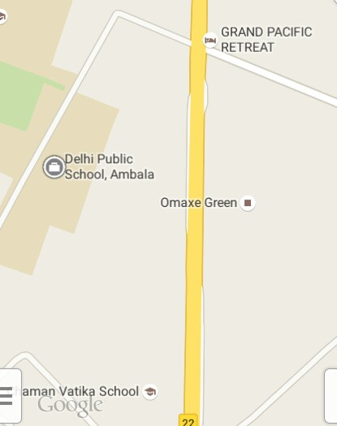  GPS Search – Delhi Public School , Ambala City.

