ALL INDIA TENNIS ASSOCIATION
NAME OF THE TOURNAMENT | GLISTER TENNIS ACADEMY AITA 50k MENS & WOMENS
NAME OF THE STATE ASSOCIATION | HARYANA TENNIS ASSOCIATION
HONY. SECRETARY OF THE ASSOCIATION | MR. SUMAN KAPUR
ADDRESS OF ASSOCIATION | kapursuman@yahoo.com
TOURNAMENT WEEK | WEEK : 13TH NOVEMBER 2017  ENTRY DEADLINE : 23RD OCTOBER 2017  WITHDRAWAL : 6TH NOVEMBER 2017
THE SCHEDULE WILL BE UPLOADED ON OUR FACEBOOK PAGE WWW.FACEBOOK.COM/GLISTERTENNISACADEMY & WEBSITE WWW.GLISTERTENNISACADEMY.COM AFTER 8PM ON THE PREVIOUS EVENING. NO REQUEST FOR TIMINGS WILL BE ACCEPTED.

THE ENTRY IS TO BE SENT BY EMAIL:  Name, AITA No., DOB, Category, Contact No. & Tournament Week applying for, to | 9953676437, 9711100237  glister.tennisacademy@gmail.com
ADDRESS OF THE VENUE | GLISTER TENNIS ACADEMY,  On Pathways School Road Baliawas, Opp. Teri Golf Course Near Gwal Pahari, Off to Gurgaon-Faridabad Road Gurgaon (H.R.).
TOURNAMENT DIRECTOR | Ankita Maan: +91 9711100237
TOURNAMENT REFEREE | Mr. Gaurav Tomar: +91 9953676437

CATEGORY () | N | ( ) | NS | ( ) | SS | ( ) | CS | ( ) | TS | ( )
AGE GROUPS () | U-12 | ( ) | U-14 | ( ) | U-16 | ( ) | U-18 | ( )
 | Men’s | ( ) |  | Women’s |  | ( )

AGE ELIGIBILITY | Players born:  No player born after 1st Jan 2003 is permitted to play Men’s / Women’s AITA Tournaments.
ENTRY FEE | Total Rs 500/- (Whether the player plays Singles or Doubles or Both)
SIGN-IN | QUALIFYING DRAW: 10/11/2017  12-2PM |  |  | MAIN DRAW: 12/11/2017  12-2PM
QUALIFYING DRAW SIZE | SINGLES | OPEN |  | DOUBLES |  | N/A
MAIN DRAW SIZE | SINGLES | 32 |  | DOUBLES |  | 16
ENTRY DEADLINE | 23rd OCTOBER 2017 |  | WITHDRAWAL DEADLINE |  | 6TH NOVEMBER 2017
HOTEL DETAILS
NAME | GOLDEN TULIP SUITES (Walking Distance) | OYO ROOMS (4.5 kms)
ADDRESS | GWAL PAHARI, GURGAON – FARIDABAD ROAD, GURGAON. | OYO PREMIUM,  Sector- 55
TARIFF (OYO ROOMS)
SINGLE | 1,299 PER ROOM
DOUBLE | 1,499 PER ROOM / 750 PER OCCUPANCY
TRIPLE | 1,799 PER ROOM / 600 PER OCCUPANCY
THE ABOVE MENTIONED ROOMS ARE INCLUSIVE OF BREAKFAST, WIFI & TAXES.

RULES / REGULATIONS

ENTRY | No entry for Main Draw will be accepted through telephone. Please carry your Original AITA ITN Card for sign in On SIGN IN DAY 12-2 pm.  QUALIFYING SIGN-IN: 10TH November 2017, 12-2PM  QUALIFYING MATCHES: 11th – 12th November 2017, 8AM – 8PM  MAIN DRAW SIGN-IN: 12th November 2017, 12-2PM  MAIN DRAW MATCHES: 13th – 17th November 2017, 8AM – 8PM
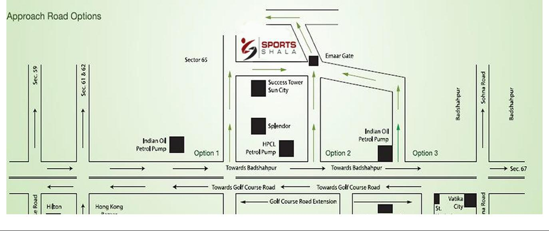

COURT SURFACE | CLAY | NO. OF COURTS: | 6 | BALLS | WILSON US-OPEN

