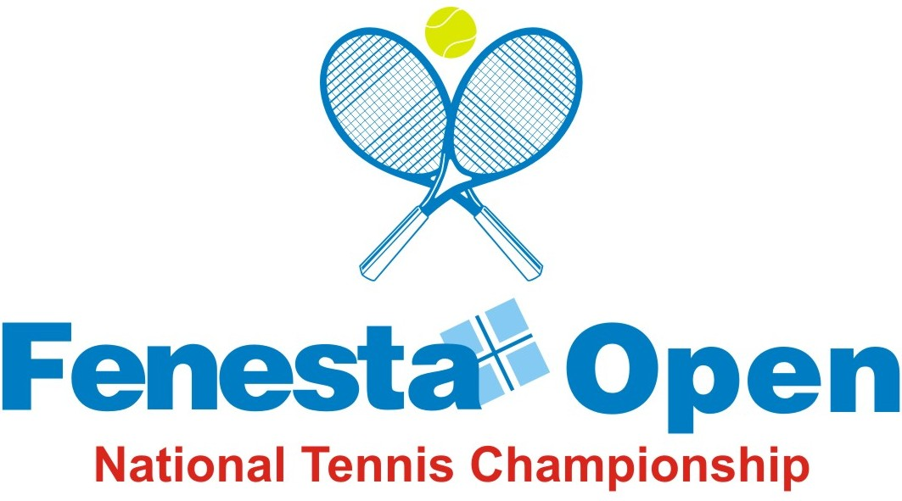

NAME OF THE TOURNAMENT | FENESTA OPEN NATIONAL TENNIS CHAMPIONSHIP-2015
NAME OF THE STATE ASSOCIATION | DELHI LAWN TENNIS ASSOCIATION
HONY. SECRETARY OF ASSOCIATION | MR V K BATRA
ADDRESS OF ASSOCIATION | DELHI LAWN TENNIS ASSOCIATION
DLTA COMPLEX, R K KHANNA TENNIS STADIUM,
No. 1, AFRICA AVENUE, NEW DELHI-110 029
TOURNAMENT WEEK | 12 OCTOBER 2015

EVENTS | ENTRY DEADLINE | WITHDRAWAL DEADLINE
Boys & Girls U-14 & U-16 | 21 Sep 2015 | 05 Oct 2015

THE ENTRY IS TO BE SENT |  | Wg Cdr P F MONTES (Retd)
ADDRESS |  | FENESTA NATIONAL TENNIS CHAMPIONSHIP-2015  ALL INDIA TENNIS ASSOCIATON  DLTA COMPLEX, R K KHANNA TENNIS STADIUM,  No. 1, AFRICA AVENUE,  NEW DELHI-110 029
TEL | 011-26176276, 26176280/1/3/4/5 |  | EMAIL | entries@aitatennis.com

NAME OF THE VENUE |  | R K KHANNA TENNIS STADIUM
ADDRESS OF VENUE |  | DLTA COMPLEX, No. 1, AFRICA AVENUE,  NEW DELHI-110 029
TELEPHONE | 011-26193955 |  | FAX | 011-26173159
COURT SURFACE | SYNTHETIC |  | BALLS | HEAD ATP

EVENTS & SIZE OF DRAW
EVENTS | QUALIFYING | MAIN DRAW
 | ROUNDS | DA | SE | Q | TOTAL
Boys (Singles) | 64 | 54 | 2 | 8 | 64
Girls (Singles) | 48 | 38 | 2 | 8 | 48
Boys & Girls U-18 (Doubles) | - | 16 | - | - | 16

DATES - SIGN-IN & MATCHES
EVENTS | SIGN-IN |  | MATCHES
 | QUALIFYING | MAIN DRAW | QUALIFYING | MAIN DRAW
Boys & Girls Singles | No Sign-in | No Sign-in | 10 & 11 Oct 2015 | 12 - 17 Oct 2015
Boys & Girls Doubles |  | Monday, 12 Oct 2015 ( Before 12 Noon) |  | 12 - 17 Oct 2015

DAILY ALLOWANCE
Boys & Girls U-18 | Rs. 1,000/- per day

ENTRY FEE | SINGLES | DOUBLES
Boys & Girls | Rs. 1,000/- | Rs. 1,200/- per pair

For Juniors AITA rules will be followed, placed on AITA website
HOTEL DETAILS
NAME | R K KHANNA TENNIS STADIUM
ADDRESS | DLTA Complex, No. 1 Africa Avenue, New Delhi-110 029
TEL | 011-26176280 / 1 / 3 / 4 / 5
Single | Rs. 2,500/- plus taxes
Double | Rs. 3,000/- plus taxes
Contact Persons | Mr Ajeet Gandhi – (Mob- 08800547515)
E-mail | gandhi_a123@yahoo.co.in

TOURNAMENT COMMITTEE

CHAIRMAN - AJAY S. SHRIRAM

VICE CHAIRMAN - VIKRAM S. SHRIRAM

MEMBERS - V K BATRA
AJIT S. SHRIRAM
SOVAN CHAKRABARTY
ANIL KUMAR
RAJAT MUKERJEI
RAJIV ARORA
SAKET JAIN
AMAN PANNU
SUSMITA NAG

TOURNAMENT DIRECTOR - MANPREET KANDHARI

ORGANISING SECRETARY - S N CHATTERJEE

REFEREE - PUNEET GUPTA

SPONSORED BY


FENESTA OPEN NATIONALS TENNIS CHAMPIONSHIP – 2015

12 0 17 October 2015

ENTRY FORM

USE CAPITAL LETTERS

- PLAYERS’S NAME ________________________________________________________

(AS PER AITA REGISTRATION)

- VALID ITN REGISTRATION NUMBER__________________________________________
(Only Players having valid ITN Registration Card are allowed to play tournament)

- DATE OF BIRTH____________________________SEX___________________________
- PERMANENT ADDRESS____________________________________________________

______________________________________________________________________

______________________________________________________________________
- CONTACT NOS.__________________________________________________________
- E-MAIL ID______________________________________________________________
- LOCAL CONTACT ADDRESS WITH TEL NO._____________________________________

______________________________________________________________________
EVENTS | TICK () | AITA RANKING | AITA POINTS
Boys U-14
Boys U-16
Girls U-14
Girls U-16

- UNDERTAKING
I have read the conditions enclosed and code of conduct, rules of ITF/AITA which shall be binding on me and I agree to abide by them. It is my responsibility to confirm the receipt and status of my entry.

Full signatures of the Player only
SPONSORED BY

