[ALL INDIA TENNIS ASSOCIATION] 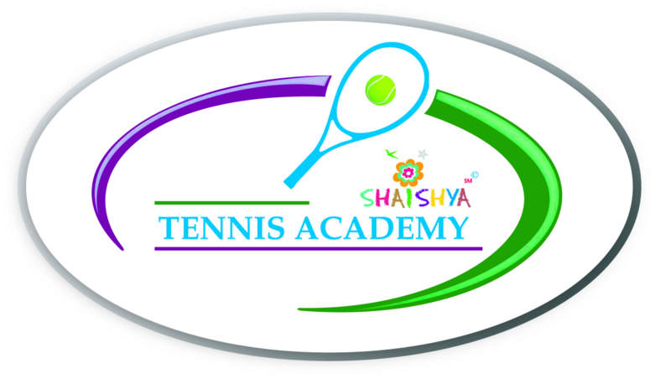
NAME OF THE TOURNAMENT | AITA SHAISHYA TPPAG CHAMPIONSHIP SERIES TOURNAMENT
NAME OF THE STATE ASSOCIATION | GUJARAT STATE TENNIS ASSOCIATION
HONY. SECRETARY OF ASSOCIATION | Mr. CHINTAN PARIKH
ADDRESS OF ASSOCIATION | GUJARAT STATE TENNIS ASSOCIATION,  NEAR. SPORTS CLUB OF GUJ.LTD.  S.P. STADIUM ROAD, NAVRANGPURA. AHMEDABDA 380009
TOURNAMENT WEEK | WEEK: 28TH November, 2016 (earlier was to be held in the week of 21st November)

THE ENTRY IS TO BE SENT |  | Supriy Christian
ADDRESS |  | SHAISHYA TENNIS ACADEMY,
 |  | IN LANE OF ARYAVAT IV,
IN LANE OPPOSITE YMCA, S.G. HIGHWAY,
AHMEDABAD - 380058
TELEPHONE |  | MOBILE | 9687833737
 |  | EMAIL | sta.tournament@gmail.com

CATEGORY () | Championship Series |  |  | ( )
AGE GROUPS () | BOYS & GIRLS U-16 | ( ) | BOYS & GIRLS U-18 |  | ( )

SIGN-IN | QUALIFYING | 25th NOVEMBER, 2016 | MAIN DRAW | 27TH NOVEMBER, 2016
MAIN DRAW SIZE | Singles | 32 | Doubles | 16
QUALIFYING DRAW SIZE | Singles | NA  (OPEN FOR ALL) | Doubles | NA
DATES FOR SINGLES | QUALIFYING | 26TH TO 27TH NOVEMBER | MAIN DRAW | 28th NOVEMBER TO 3RD DECEMBER
DATES FOR DOUBLES | QUALIFYING | NA | MAIN DRAW | 28TH NOVEMBER TO 3RD DECEMBER
ENTRY DEADLINE | 7TH NOVEMBER, 2016 | WITHDRAWAL DEADLINE |  | 21ST NOVEMBER, 2016

NAME OF THE VENUE |  | SHAISHYA TENNIS ACADEMY
ADDRESS OF VENUE |  | SHAISHYA TENNIS ACADEMY,  IN LANE OF ARYAVAT IV,  IN LANE OPPOSITE YMCA  S.G. HIGHWAY,  AHMEDABAD - 380058
TELEPHONE | (Venue contact number –9687833737 8866050100) | EMAIL | sta.tournament@gmail.com
COURT SURFACE | HARD COURTS – SHADED | BALLS | TBO
NO. OF COURTS | 04 | FLOODLIT | YES (04)

TOURNAMENT DIRECTOR |  |  | Mr. Shrimal Bhatt
TELEPHONE |  | 9327155400 | EMAIL | shrimal@shrimalbhatt.com
TOURNAMENT REFEREE | Devinder Singh
TELEPHONE |  | 8866050100 | Email | devinder@samasamtennis.com
(Continued on next page)

HOTELS DETAIL

NAME | ADDRESS | CONTACT DETAILS
CORPORATE RESIDENCY | DEV ARC MALL, S.G.HIGHWAY | Phone: 079-26921095  98244 82357
HOTEL AVION INN | 3rd Floor, Aarambh Complex, Opp. Andaz Party Plot,  Nr. Divya Bhaskar, Makarba, S.G.Highway,  (Situated at walking distance from the venue) | +91 97141 17888  www.hotelavioninn.com
HOTEL MUKUND INN | 5th FLOOR IBS HOUSE, NEAR GNFC TOWER, NEAR GRAND BHAGWATI, SG HIGHWAY, BODAKDEV. | 079 - 2685 8341,  079 - 2685 8342  http://www.hotelmukund.com/
SILVER LEAF HOTEL | GORDHAN THAL, OPP RAJPATH CLUB, SARKHEJ GANDHINAGAR HIGHWAY, | +(91)-(79)-26870111

RESTAURANTS DETAIL

NAME | FOOD | DISTANCE
HONEST | PUNJABI, SOUTH INDIAN, SNACKS | 1 K.M
HAVMOR | PUNJABI, SNACKS | 1.5 K.M.
KFC | BURGER, SNACKS, BEVERAGES | 1.5 KM
SUBWAY | SANDWICH, SUBS | 1.5 KM
SOUTHLAND FAST FOOD | FAST FOOD | 1.5 KM

(Continued on next page)

RULES / REGULATIONS
AGE ELIGIBILITY | Players born:  On or After 1st Jan 1998 are eligible for participation in U/18  On or After 1st Jan 2000 are eligible for participation in U/16  Also  No player born after 01 Jan 2004 is permitted to play Under 18 AITA tournaments.  No player born after 01 Jan 2006 is permitted to play Under 16 AITA tournaments.
ENTRY FEE | SERIES SINGLES FEE DOUBLES FEE  CHAMPIONSHIP SERIES Rs. 500/- Rs 600/- pair
DAILY ALLOWANCE | Rs.400 / day PER DAY DA to be paid for days the player is in the Singles / Doubles Main Draw
AITA Registration Card | It is mandatory for the player to carry ORIGINAL REGISTRATION CARD for the sign-in. In case the player registration is in process with AITA, the player has to carry Original receipt or copy of mail from AITA confirming that player registration is in process.
MATCH FORMAT | Singles  Qualifying Rounds: Best of 17 Games  Final Qualifying Round: Best of three tie break sets (Deuce 2 points)  Main Draw Matches: Best of 3 Tie Break sets with Deuce 2 pts.  Doubles  Size of Draw will be of 16 pairs  First two sets would be normal Tie-Breaker Sets with No Advantage scoring i.e. Deuce 1 Point. A 10 Point Match Tie Break will be played  in lieu of the Final Set.  Acceptance List will be made from the AITA Rankings by adding the Ranking of each of the players in the pair.

