ALL INDIA TENNIS ASSOCIATION
NAME OF THE TOURNAMENT | SPORTSSHALA AITA CHAMPIONSHIP SERIES - 7  Boys & Girls U-14 & 16
NAME OF THE STATE ASSOCIATION | HARYANA TENNIS ASSOCIATION
HONY. SECRETARY OF THE ASSOCIATION | MR. SUMAN KAPUR
ADDRESS OF ASSOCIATION | kapursuman@yahoo.com
TOURNAMENT WEEK | WEEK : 12TH JUNE 2017  ENTRY DEADLINE : 22ND MAY 2017  WITHDRAWAL : 5TH JUNE 2017
THE SCHEDULE WILL BE UPLOADED ON OUR FACEBOOK PAGE WWW.FACEBOOK.COM/SPORTSSHALAINDIA & WEBSITE WWW.SPORTSSHALA.COM AFTER 8PM ON THE PREVIOUS EVENING. NO REQUEST FOR TIMINGS WILL BE ACCEPTED.

THE ENTRY IS TO BE SENT BY EMAIL ONLY  Name, AITA No., DOB, Category, Contact No. & Tournament Week applying for, to | Miss. Ananya Paul  ananya.paul@passerinegroup.com
ADDRESS OF THE VENUE | SPORTS SHALA,  SECTOR -65, GOLF COURSE EXTENSION ROAD, INSIDE EMAAR MGF COMPLEX, EMERALD HILLS  GURGAON (HARYANA)
TOURNAMENT DIRECTOR | Miss. Ananya Paul: +91 9711772894
TOURNAMENT REFEREE | Mr. Jaswant Nigam: +91 9911346692

CATEGORY () | N | ( ) | NS | ( ) | SS | ( ) | CS | () | TS | ( )
AGE GROUPS () | U-12 | ( ) | U-14 | ( ) | U-16 | ( ) | U-18 | ( )
 | Men’s | ( ) |  | Women’s |  | ( )

AGE ELIGIBILITY | Players born:  After 1st Jan 2003 are eligible for participation in U-14  After 1st Jan 2001 are eligible for participation in U-16
ENTRY FEE | SERIES SINGLES FEE DOUBLES FEE  CS Boys & Girls Rs. 500/- Rs 600/- pair
SIGN-IN | QUALIFYING DRAW: 9-JUN-2017  12-2PM |  |  | MAIN DRAW: 11-JUN-2017  12-2PM
QUALIFYING DRAW SIZE | SINGLES | OPEN |  | DOUBLES |  | N/A
MAIN DRAW SIZE | SINGLES | 32 |  | DOUBLES |  | 16
ENTRY DEADLINE | 22ND MAY 2017 |  | WITHDRAWAL DEADLINE |  | 5TH JUNE 2017
HOTEL DETAILS
NAME | OYO ROOMS (5.0 kms) | OYO ROOMS (7.9 kms)
ADDRESS | Near Double Tree by Hilton,  Sector- 56 | OYO Premium,  Golf Course Road,  Sector- 54
TARIFF
SINGLE | 1,299 PER ROOM
DOUBLE | 1,499 PER ROOM / 750 PER OCCUPANCY
TRIPLE | 1,799 PER ROOM / 600 PER OCCUPANCY
THE ABOVE MENTIONED ROOMS ARE INCLUSIVE OF BREAKFAST, WIFI & TAXES.

RULES / REGULATIONS

ENTRY & DIRECTIONS | No entry for Main Draw will be accepted through telephone. Please carry your Original AITA ITN Card for sign in On SIGN IN DAY 12-2 pm to escape a penalty of Rs. 100/-  QUALIFYING SIGN-IN: 9TH JUNE 2017, 12-2PM  QUALIFYING MATCHES: 10TH – 11TH JUNE 2017, 8AM – 8PM  MAIN DRAW SIGN-IN: 11TH JUNE 2017, 12-2PM  MAIN DRAW MATCHES: 12TH – 16TH JUNE 2017, 8AM – 8PM

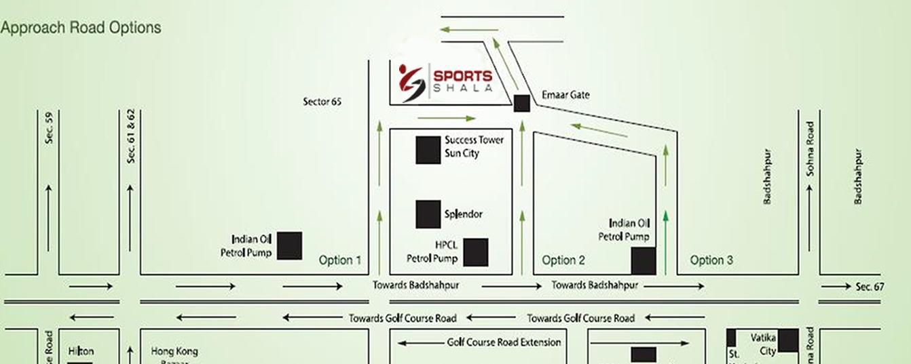

COURT SURFACE | CLAY | NO. OF COURTS: | 5 | BALLS | BABOLAT

